**TUTORIAL 6**

1. Given the following information for a one-year project, answer the following questions.

*PV=$23,000 EV=$20,000 AC=$25,000 BAC=$120,000*

1. What is the cost variance, schedule variance, cost performance index (CPI), and schedule performance index (SPI) for the project?
2. How is the project doing? Is it ahead of schedule or behind schedule? Is it under budget or over budget?

Behind schedule because the SPI <100%.

Over budget, because CPI<100%

1. Use the CPI to calculate the estimate at completion (EAC) for this project. Is this project performing better or worse than planned?

eac=bac/cpi=150000

1. Use the SPI to calculate the estimate how long it will take to finish this project.

Time=Original time / spi=12/0.8696=13.79 months=13 months 24 days

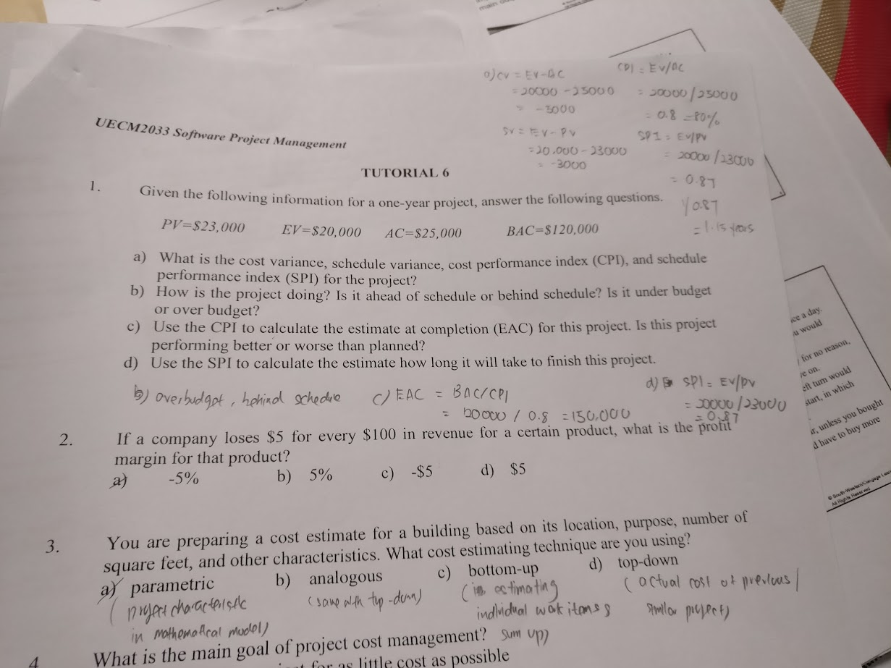

1. If a company loses $5 for every $100 in revenue for a certain product, what is the profit margin for that product?
2. -5% b) 5% c) -$5 d) $5
3. You are preparing a cost estimate for a building based on its location, purpose, number of square feet, and other characteristics. What cost estimating technique are you using?
4. parametric b) analogous (The previous) c) bottom-up d) top-down
5. What is the main goal of project cost management?
6. To complete a project for as little cost as possible
7. To complete a project within an approved budget
8. To provide truthful and accurate cost information on projects
9. To ensure that an organization’s money is used wisely
10. _____________ is a project performance measurement technique that integrates scope, time, and cost data.
11. Reserve analysis b) Life cycle costing

c) Project cost budgeting d) Earned value analysis

1. Give an example in software project management for each of the following terms.
2. Direct cost : The salary of team member
3. Indirect cost: The cost toilet paper
4. Sunk cost: The cost of Laptop were purchased in the previous project and it will not be considered as the cost of current project.